Moderator analysis on word characteristics

To examine the extent to which features of target words affect the relationship between frequency and vocabulary learning, we conducted a series of moderator analyses. Word characteristics were operationalized in the following ways:

1. Average number of letters per word
2. Average number of syllables per word
3. Proportion of nouns to the total number of target words
4. Frequency (COCA, Davies, 2009)
   * Average four sub-corpora: Academic, Fiction, Magazine, News, Spoken
5. Concreteness (MRC Psycholinguistic Database, Coltheart, 1981)
6. Familiarity (MRC Psycholinguistic Database, Coltheart, 1981)
7. Imageability (MRC Psycholinguistic Database, Coltheart, 1981)
8. Meaningfulness (MRC Psycholinguistic Database, Coltheart, 1981)
9. Age of acquisition (MRC Psycholinguistic Database, Coltheart, 1981)

Word characteristics from 4 to 9 were measured using the Tool for the Automatic Analysis of Lexical Sophistication (TAALES) (Kyle & Crossley, 2015). For the analysis of the first two features (i.e., average number of letters and syllables per word), nonwords used in the following studies (Hatami, 2017; Reynolds, 2018; van Zeeland & Schmitt, 2013; Wenzhong & Feng, 2009) were used without any change. For the analysis of the frequency and five psycholinguistic properties, real words that were replaced with nonwords were used (Elgort & Warren, 2014).

Pearson correlations between 9 variables and the weighted mean effect sizes (i.e., correlation between frequency of encounters and leaning gains) were conducted along with the presentation of each scatterplot. The results were summarized in Table 1 and the relationship between each word characteristic and frequency effects was illustrated in Figures 1 to 9.

Overall, none of the correlation coefficients reached a statistical significance, and the effect sizes were all marginal (*r* < .20, *p* > .05). The scatterplots of frequency and meaningfulness might deserve further exploration (see Figures 4 and 8). Regarding word frequency, the relationship shows that the majority of target words cluster near a frequency value of 0 (= low frequency). This result makes sense since low frequency words tend to be selected as target words. The scatterplot regarding meaningfulness (Figure 8) shows two clear outliers. Another correlation analysis was conducted after the outliers were removed, but the result did not reveal any significant relationship, *r* = .07, *p* = .63.

Summary of Results

Table 1. Moderator Analysis (Word Characteristics)

|  |  |  |  |  |  |
| --- | --- | --- | --- | --- | --- |
|  | k | r | LL | UL | p |
| Letters | 42 | -.05 | -.37 | .26 | .73 |
| Syllables | 42 | -.01 | -.33 | .30 | .91 |
| Noun proportion | 42 | -.05 | -.37 | .26 | .71 |
| Frequency | 42 | -.13 | -.45 | .18 | .39 |
| Concreteness | 42 | -.08 | -.39 | .23 | .61 |
| Familiarity | 42 | -.05 | -.37 | .25 | .71 |
| Imageability | 42 | -.01 | -.24 | .39 | .94 |
| Meaningfulness | 42 | .07 | -.24 | .39 | .63 |
| Age of acquisition | 42 | .02 | -.29 | .34 | .88 |

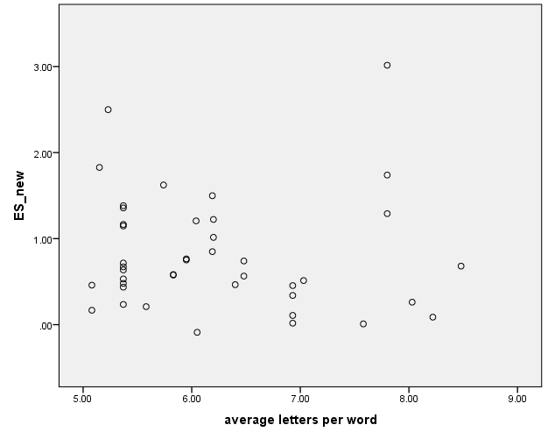

Figure 1. Average number of letters per word

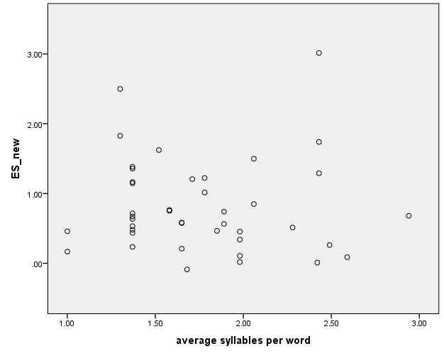

Figure 2. Average number of syllables per word

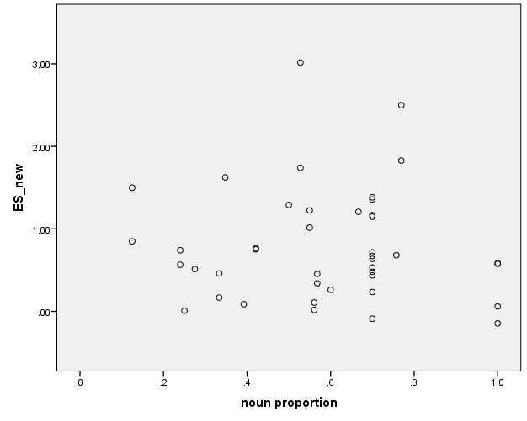

Figure 3. Noun proportion

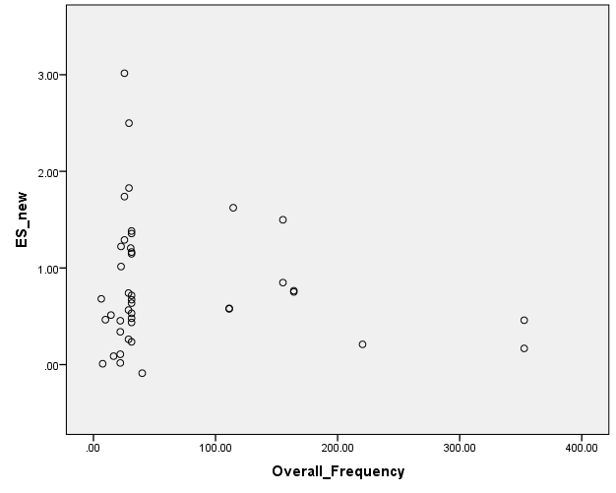

Figure 4. Frequency

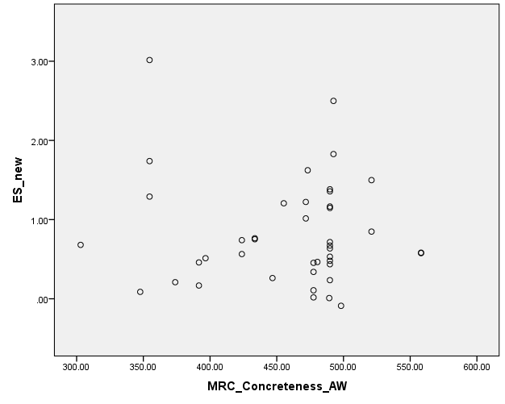

Figure 5. Concreteness

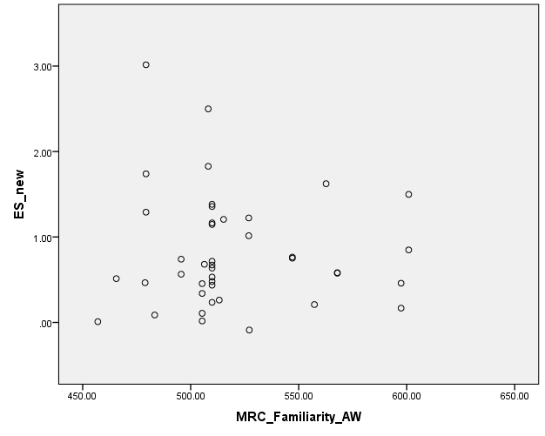

Figure 6. Familiarity

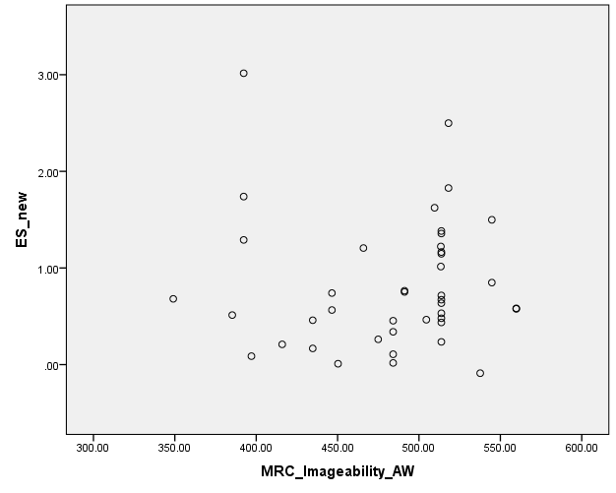

Figure 7. Imageability

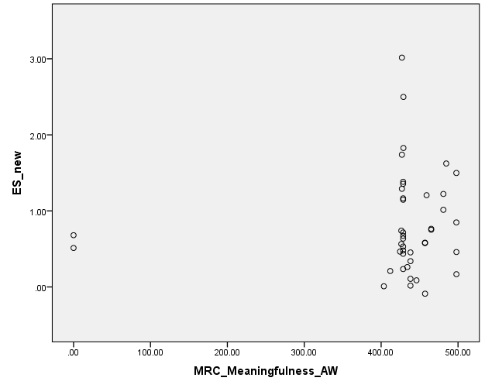

Figure 8. Meaningfulness

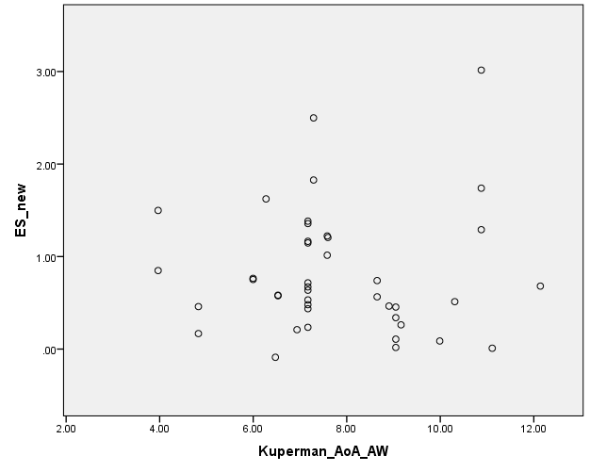

Figure 9. Age of acquisition

Moderator analysis on text length

In order to examine the extent to which text length (*M* = 12,119.1, *SD* = 18476.9, *Range* = 316 to 66,938) influences frequency effects, moderator analysis was conducted.

The result showed a small negative correlation between text length and frequency, k = 41, r = -.261 (rho = -.326), 95% [-.571, .049] (see Figure 1 for the scatterplot). The small effect size and the 95% CI that crosses zero suggest that although there seems a negative association between text length and frequency (i.e., the longer the text, the smaller the frequency effect), the effect was marginal.

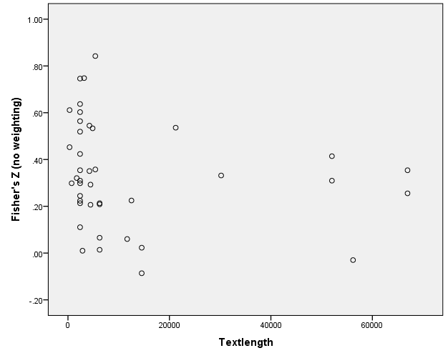

Figure 1. Relationship between text length and effect sizes (frequency-learning association).